Model Airplane Landing Gear

### (Product Design Specification)

Chris Toner

Abram Fouts

Arturo Espino

Dennis Sorokin

Team 8

Ece-411

Fall 2019

Table of Contents

Abstract 4

Introduction 4

Market Analysis 5

Requirements 6

System Architecture 7

Block Diagram 7

Design Specification 7

Documentation 7

# Abstract

We are designing an airplane landing gear. This will be done using servo motors, a processor, and an infrared range finder. This scaled-down version of airplane landing gear serves the purpose of learning how state machines are used in everyday life. This model will emulate real-life airplane landing gear that will be scaled down to model airplane size.

# Introduction

Ever since planes were first imagined soaring into the skies, there has been a dual side of that coin: what to do when we want them to come back down. Hot air balloons rise and fall slowly thanks to the use of thermodynamics, and planes have always had more complicated physics to deal with. This was solved by the advent of landing gear to allow a plane to come to a rolling stop when touching down.

As technology moves towards more and more automation of simple tasks, we find ourselves finding new things that we can remove human calculations from, thus reducing human error. We can achieve this as well with landing gear. Our objective is to create a model plane system with wheels that detract and retract when reaching a certain distance from the ground. This would be the first step in creating a larger, more inclusive system that can include such variables as speed, pressure, or wind resistance.

This device will be marketed towards the model airplane enthusiasts: RC hobbyists as well as non-functioning airplane hobbyists, though to a smaller extent. We believe that this device can also be applicable to the exploding unmanned aircraft community and can be ported to heavier drones that may need a physical landing space as opposed to smaller versions that operators simply carry by hand.

# Market Analysis

Our landing gear product can eventually be adapted for a variety of unmanned model airplanes. According to the FFA governmental agency for unmanned aircraft systems (UAS), “With the continuing registration, more than 900,000 owners had already registered with the FAA by Sept. 2018. Monthly owner registration averaged around 8,000-9,000 during Jan.-Dec. 2018, with some expected peaks during the holiday season and summer.”[1]

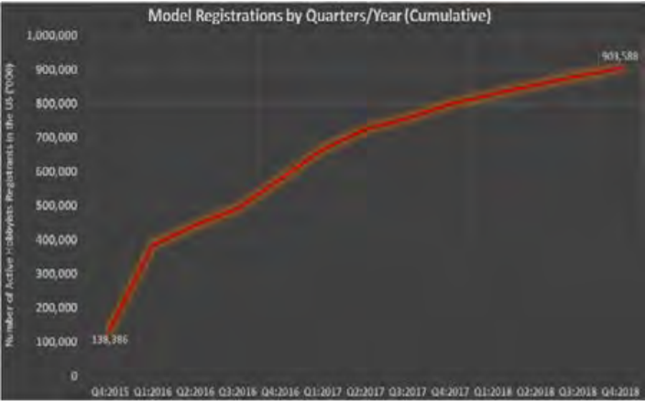

Figure 1 - Model registrations (All figures taken from FAA.gov)

Unmanned Aircraft Systems (UAS) are required to be registered with the government. This creates a verifiable marketplace and trends can be quite predictable. While sales are predicted to slow in the coming years as enthusiasm with new technologies (namely drones) fades, hobbyists tend to be very dedicated and bullish on keeping up with trends. Many users tend to own multiple aircraft and having an affordable retractable landing gear system could be a boon to save costs for these hobbyists while maintaining their own craft interests.

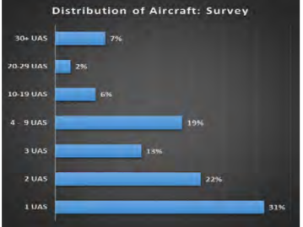

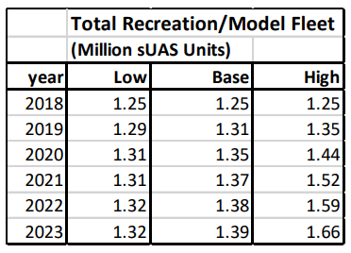Not all of these owners have a new need for retractable landing gear, obviously. Doing a brief online search shows plenty of models with their own retractable landing gear. The prices for some of these planes, however, can be quite exorbitant, reaching well over $1000. By the amount of people who also have tutorials online on how to build your own landing gear, there is clearly a demand for an affordable product. We live in a time of DIY craft enthusiasts, but not everyone has the time or knowledge to build complicated embedded systems such as our product. By offering clients a smaller - yet complicated - product part they can use to build upon model planes they already own, we can fill a niche that would otherwise go to these high-end plane models.

# Requirements

* The system must retract the landing gear if the plane is 4 inches or more above the surface as measured from the bottom of the wheel. Our current wheel selection is 11 inches, so we estimate the distance from the ground to the bottom of the plane when the landing gear retracts will be around a foot assuming that part of the wheel struts included in the measurement will reside within the plane shaft itself. This may be updated upon construction.
* The system must extend the landing gear when the sensor detects a distance to ground of about a foot.
* Our system must power our board and three servo motors from a 5V source
* Our system should be under $40 to manufacture
* Our model should reflect a reasonable model of the body of an RC place
* The system may have an LED that will blink upon the opening or closing of the landing gear.
* Our system may be easily portable to connect to a different plane with similar dimensions
* May use a properly modeled airplane
* May be visually appealing for product demonstration purposes
* Our model may include real time sensor data with the belief that it can be used for educational purposes as well

# System Architecture

## Block Diagram

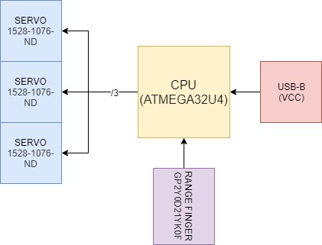

# Design Specification

* Processor - ATMEGA32U4-AUR
* Servos - SERVO MOTOR 5VDC TOWERPRO SG92R
* Sensor - SENSOR OPTICAL 24CM DIGITAL
* Power - USB B Receptacle Connector 4 Position Through Hole, Right Angle
* Arduino for adafruit servo
* Development environment C/C++

# Documentation

* GitHub will be the main source of revision control
* Google docs for real time collaboration projects
* EagleCAD for design schematics

1. <https://www.faa.gov/data_research/aviation/aerospace_forecasts/media/unmanned_aircraft_systems.pdf>